
Name: _________________________________

Task 10:

SOURCE ANALYSIS, FORTNIGHTLY TASK FIVE Weighting 2% (9 Marks)

Question 1

- Explain the historical context of Source 1. Include the relevant events, people and ideas depicted or represented in the source.
(4 marks)

- Compare and Contrast the purpose of Sources 1 and 2. (5 marks)

Source Booklet:

Source 1:

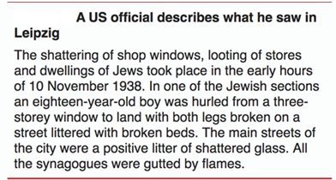

Source 2:
